**CHAPTER IV**

# RESULTS AND DISCUSSION

The experiment was conducted at Instructional Farm, Soil and Water Conservation Engineering Department, College of Agricultural Engineering and Technology, Junagadh Agricultural University, Junagadh to develop a smart runoff measurement system for measurement of runoff depth and send data to webpage for storing and visualization. The observed data were analyzed to evaluate the performance of ultrasonic sensors, and the results obtained are discussed in this chapter.

**4.1 Smart runoff measurement system**

Smart runoff measurement system has been developed to measure runoff depth or runoff volume in pre-decided interval of time at runoff plot. It is dire need to develop the smart runoff measurement controller which works independently using Internet of Things(IoT). The user-friendly third party website is used to monitor the system remotely as well as minimize human intervention.

The developed smart system required very low power. The 12 V and 5 V DC battery power is supplied to controller from solar-generated power unit to remain it always in ON condition. The Wi-Fi modules start searching for Wi-Fi networks as soon as the power is available to the controller and once it finds the given SSID and PASSWORD, it gets connected to Wi-Fi. Ultrasonic sensors get command from controller to measure depth of runoff water in runoff tank in pre-decided interval of time. Raw data from sensor is sent to the microcontroller for processing, which is done by various functions. Processed data is sent to NodeMCU via I2C serial communication protocol from the microcontroller. NodeMCU published data into third party website for visualization and cloud storage purposes. The data which is stored in this website can be downloaded easily and it can be analyzed and also generate hydrograph.

**4.1.1 Flow chart of working of smart runoff measurement system:**

Flow chart of working of smart runoff measurement system is given in the flow chart depicted in Fig. 4.1.

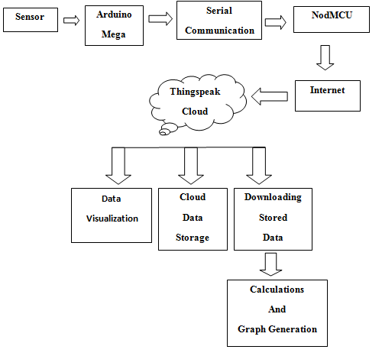

**Fig 4.1 Flow chart of working of smart runoff measurement system**

**4.2 Validation of Ultrasonic Sensor**

Ultrasonic sensor transmits an ultrasonic sound pulse when we give 10 microseconds pulse to trigger pin. This ultrasonic pulse is reflected if any obstacles are coming on its way. Receiver listens to this ultrasonic pulse and calculates the time required to return pulse. According to the time required it can calculate distance between sensor and obstacle. We programmed ultrasonic sensor by three different methods.

(1) Using New Ping Library

(2) Using New Ping Library and Iterations

(3) Using New Ping Library and Temperature Effect Equation

**4.2.1 New Ping LibraryMethod**

Instead of triggering the ultrasonic sensor and measuring the received signal pulse width manually, we used a special library. There are quite a few of them available, the most versatile is one called “NewPing”. The NewPing library is quite advanced and it considerably improves upon the accuracy of our original sketch. It also supports up to 15 ultrasonic sensors at once and it can directly output in centimeters, millimeters, inches or time duration. We can use 3 wire interface to connect ultrasonic sensors and microcontroller by using NewPing library. The manual measured and sensor measured runoff depth using Newping library is given in table 4.1.

**Table 4.1 The manual measured and sensor measured runoff depth using newping library.**

|  |  |  |  |  |
| --- | --- | --- | --- | --- |
| Sr. No. | Sensor Reading(mm) | Manual Reading(mm) | Absolute Error(mm) | Relative Error(%) |
| 1 | 680 | 680 | 0 | 0 |
| 2 | 650 | 656 | 6 | 0.91 |
| 3 | 623 | 630 | 7 | 1.11 |
| 4 | 600 | 605 | 5 | 0.82 |
| Mean Error |  |  | 4.5 | 0.71 |

**Fig.4.2 The manual measured and sensor measured runoff depth using new ping library.**

It is clear from table 4.1 that the mean absolute error of sensor reading and manual reading is 4.5 mm and the relative error of sensor reading and manual reading is 0.71%.

**4.2.2 New Ping Library and Iterations method**

To improve the accuracy of ultrasonic sensor to the next level, there’s another function in NewPing library called “iterations”. To iterate means to go over something more than once, and that’s precisely what the iteration mode does. It takes many duration measurements instead of just one, throws away any invalid readings and then averages the remaining ones. By default, it takes 5 readings but it can specify as many as wish. The manual measured and sensor measured runoff depth using iteration method is given in table 4.2.

**Table 4.2 The manual measured and sensor measured runoff depth using iteration method.**

|  |  |  |  |  |
| --- | --- | --- | --- | --- |
| Sr. No. | Sensor Reading(mm) | Manual Reading(mm) | Absolute Error(mm) | Relative Error(%) |
| 1 | 566 | 570 | 4 | 0.7 |
| 2 | 544 | 550 | 6 | 1.09 |
| 3 | 527 | 530 | 3 | 0.56 |
| 4 | 507 | 515 | 8 | 1.55 |
| Mean Error |  |  | 5.25 | 0.97 |

**Fig.4.3 The manual measured and sensor measured runoff depth using iteration method.**

It is clear from table 4.2 that the mean absolute error of sensor reading and manual reading is 5.25 mm and the relative error of sensor reading and manual reading is 0.97%.

**4.2.3 New Ping Library and Temperature Effect Equation Method**

Temperature is also a condition that affects the speed of sound. Heat, like sound, is a form of kinetic energy. Molecules at higher temperatures have more energy, thus they can vibrate faster. Since the molecules vibrate faster, sound waves can travel more quickly. For **ultrasonic sensors**, this variance can affect accuracy, since a faster or slower echo return will make a stationary target appear closer or farther away. The manual measured and sensor measured runoff depth using Temperature effect method is given in table 4.3.

* Equation of speed of sound:

V = (331.296 + [0.606 × T])

Where, v = Speed of sound (m/sec)

T = Temperature of Air (°C)

**Table 4.3 The manual measured and sensor measured runoff depth using New Ping library and temperature effect equation method**

|  |  |  |  |  |
| --- | --- | --- | --- | --- |
| Sr. No. | Sensor Reading(mm) | Manual Reading(mm) | Absolute Error(mm) | Relative Error(%) |
| 1 | 487 | 490 | 3 | 0.61 |
| 2 | 468 | 470 | 2 | 0.42 |
| 3 | 455 | 460 | 5 | 1.08 |
| 4 | 443 | 445 | 2 | 0.44 |
| Mean Error |  |  | 3 | 0.63 |

**Fig 4.4 The manual measured and sensor measured runoff depth using New Ping library and temperature effect equation method.**

It is clear from table 4.3 that the mean absolute error of sensor reading and manual reading is 3 mm and the relative error of sensor reading and manual reading is 0.63%.

1. By using **NewPing Library** mean absolute error and the relative error is **4.5 mm** and **0.71%** of distance measured respectively.
2. By using **NewPing Library with iteration method** mean absolute error and the relative error is **5.25 mm** and **0.97%** of distance measured respectively.
3. By using **NewPing Library with temperature effect equation method** mean absolute error and the relative error is **3 mm** and **0.63%** of distance measured respectively.

So, From above result it is recommended to use **NewPing Library with temperature effect equation method** to measure distance using ultrasonic sensor

**4.3 Third Party Website for Data Storage & Visualization**

We used Thingspeak.com as a third-party platform for data storage and visualization. Thingspeak is open-source platform made for Internet of Things (IoT) device developers and learners where developers can send and log data to the server, analyses, retrieve and store results using graphs with Matlab support. To send data to thingspeak we need something called **API key** from our account which needs to be inserted in the program code.

**4.3.1 Thingspeak Basics and Account Setup**

For storage of data, we have to Sign Up for account and create a channel. A channel is a source for your data. Where you can store and retrieve data. A channel can have maximum 8 fields. It means you can store 8 different data to a channel

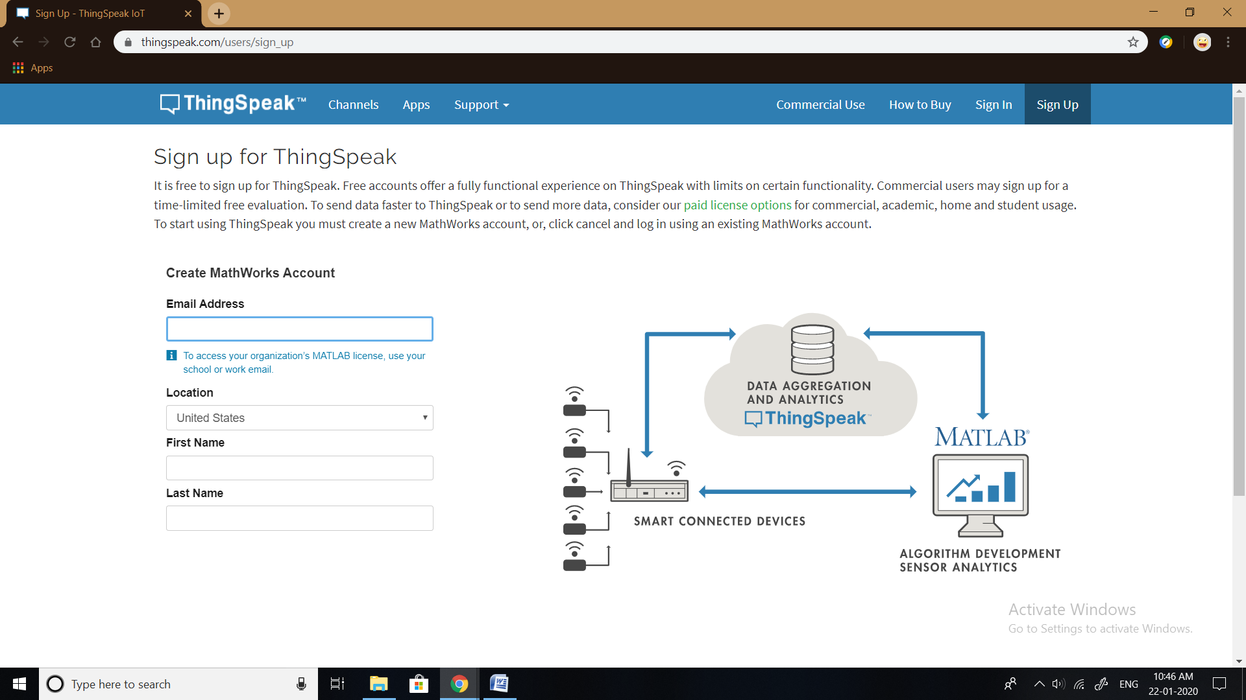

**Fig. 4.5 Thingspeak basics and account setup**

**4.3.2 Channel & API Keys**

We create a channel which name is smart runoff measurement system having Channel ID: **901536**. We keep this channel access as a private. On a channel page following six tabs are appeared.

**Private View**: This tab displays information about your channel that only you can see.

**Public View**: If you choose to make your channel publicly available, use this tab to display selected fields and channel visualizations.

**Channel Settings**: This tab shows all the channel options you set at creation. You can edit, clear, or delete the channel from this tab.

**Sharing**: This tab shows channel sharing options. You can set a channel as private, shared with everyone (public), or shared with specific users.

**API Keys**: This tab displays your channel API keys. Use the keys to read from and write to your channel.

**Data Import/Export**: This tab enables you to import and export channel data.

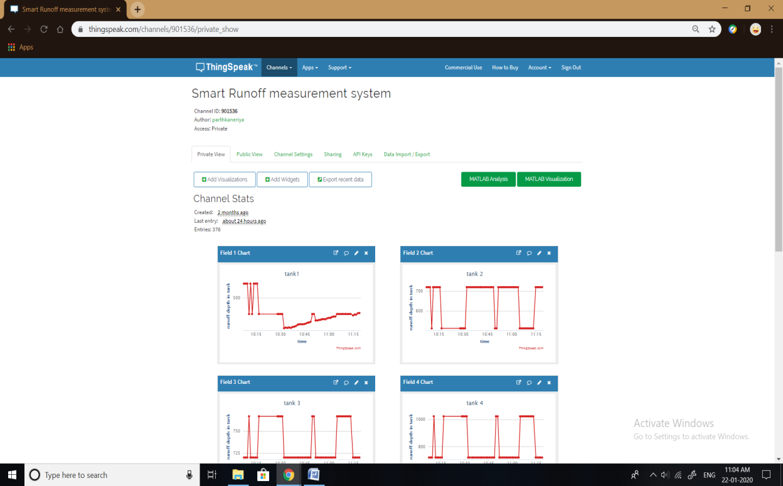

**Fig. 4.6 Smart runoff measurement system channel in Thingspeak**

API ( Application Programming Interface ) keys are the keys to access channel. In simple language, these are password to access channel. We can access channel in two ways-

1. To update channel/data logging: API Write Key will be used to access in this mode.
2. To retrieve data: API Read Key will be used to access this mode.

**4.3.3 Data Downloading**

‘Data Import/Export’ tab is used to import the ‘Comma Separated Values (CSV)’ data from a file into the channel. We can also download the channel’s feed from here in CSV format. This tab also outlines how to send and view data by providing the URIs to the send and view APIs.

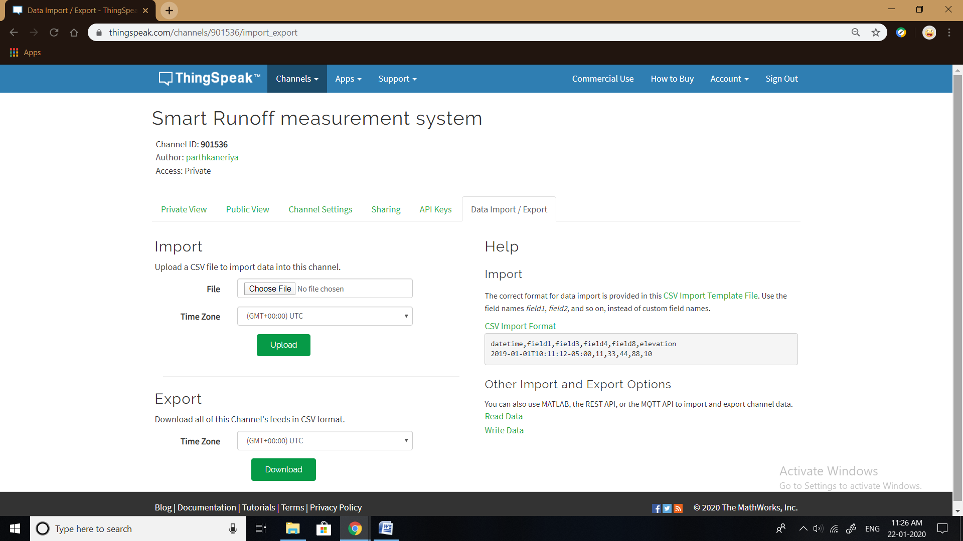

**Fig. 4.7 Data downloading Page**

**4.4 Sample calculation on download data & Graph generation :**

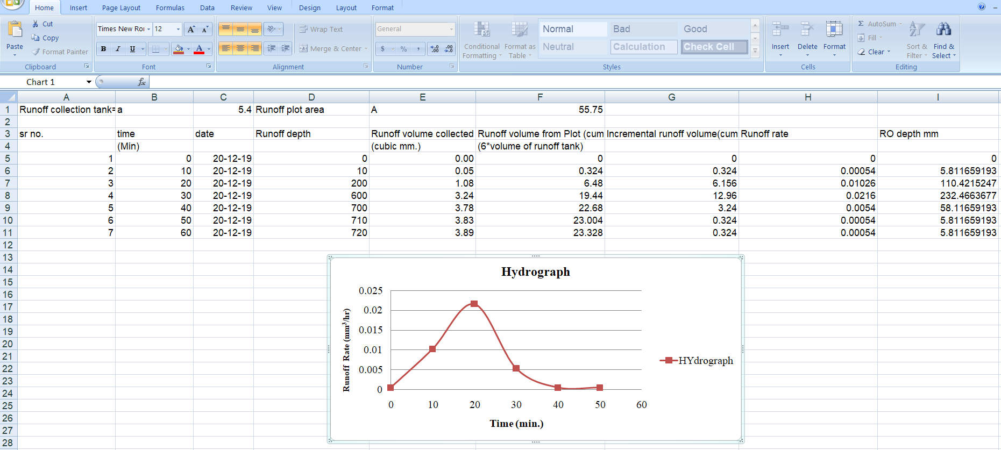

**Fig.4.8 Sample calculation of downloaded data and Generated hydrograph**

**Size of runoff collection tank:**

|  |  |
| --- | --- |
| Length of the runoff collection tank | **= 3 m** |
| Width of the runoff collection tank | **= 1.8 m** |
| Depth of the runoff collection tank | **= 0.8 m** |

**Total area of collection tank (a)** = Length of collection tank × Width of the collection tank

= 3 × 1.8

= 5.4 m2

**Runoff volume** = Area of the runoff collection tank × Increase depth of water in the collection tank

**Total runoff volume from plot** = Runoff volume × 6

(Because 1/6th part of runoff diverted into the tank)

**Runoff Depth** = Total runoff volume from plot ÷ Area of runoff plot

**Runoff rate** = Incremental runoff volume ÷ Time

So, we can analyze runoff data and generate the hydrograph by plotting runoff rate versus time

**4.5 Cost estimation and economics of smart runoff measurement system**

The estimated cost of smart runoff measurement system is near about 10040 INR. The cost of the system found very less as compared to the manual method which required labour cost near about 8000 per month. Yearly cost for labour is around 40000 which is much more compared to the smart system.

**Table no.4.4 Cost estimation of smart runoff measurement system**

|  |  |  |  |
| --- | --- | --- | --- |
| Item | Quantity | Rate INR | Amount INR |
| Arduino Mega | 1 | 780 | 780 |
| Wi – Fi Module | 1 | 350 | 350 |
| Ultrasonic Sensor | 13 | 150 | 1950 |
| Single Core Wire | 3*90 m | 350 | 1050 |
| Bread Board | 2 | 80 | 160 |
| UPVC pipe | - | - | 3400 |
| Solar Panel | 1 | 1000 | 1000 |
| Battery | 1 | 900 | 900 |
| Charge Controller | 1 | 450 | 450 |
| Total Cost | | | 10040 INR |

**By smart runoff measurement system:**

Now purchase cost (PC) = 10400 INR

Annual cost = $\frac{PC × i{(1+i)}^{n}}{{(1+i)}^{n}-1}$

Where, PC is Purchase price

i is Interest rate which is taken as 10%

n is number of life in terms of year

So, Annual cost = $\frac{10400 × 0.1{(1+0.1)}^{5}}{{(1+0.1)}^{5}-1}$

= $\frac{10400 × 0.1 ×1.6105 }{0.6105}$

= 10400 × 0.2638

= 2744 INR

**Manual Method Cost Estimation:**

Suppose labour is required for measurement of runoff depth.

It can be cost up to 8000 INR month

So,

Total annual cost = 8000 × 5

= 40000 INR

Where 5 is the month of the rainy season in one year

**Cost-Benefit Ratio:**

Comparison of the present value of an investment decision or project with its initial cost. A ratio of greater than one indicates that the project is a viable one.

Cost-Benefit Ratio = $\frac{Manual Method Cost}{Project Cost}$

= $\frac{40000}{2744}$

= 14.57

The cost-benefit ratio is greater than one so the project is viable.